Final Project Report

Optimizing I/O Throughput in Software-Defined Storage via Adaptive Caching Mechanisms

Project Details
College/University: GSSS Institute of Engineering and Technology for Women, Mysuru
Participants: Swasti M Petkar, Shreelekha Gundal, Likhitha H U, Maanvi Chandan, Rachana N,DivyaKN
Mentors: Mr. M S Shekar (External HPE Mentor), Dr. Rajath A N (Internal Mentor)

1. Problem Statement

Modern enterprise applications such as cloud platforms, virtualization environments, databases, and AI workloads continuously perform large volumes of read and write operations. As data grows, traditional HDD-based storage systems experience increased latency and reduced throughput, especially during random access and RAID parity operations. These limitations directly impact application performance and overall system responsiveness.

This project presents an automated Software Defined Storage (SDS) solution that improves storage performance through intelligent SSD-based adaptive caching while maintaining the reliability of RAID 6. The storage environment was implemented on Rocky Linux using open-source technologies including mdadm, Logical Volume Manager (LVM), LVM Cache, XFS filesystem, Python automation, FIO benchmarking, InfluxDB, and Grafana.

A Python automation tool was developed to simplify the complete storage provisioning process by automatically detecting disks, configuring RAID 6, creating logical volumes, attaching SSD cache, mounting the filesystem, executing benchmark workloads, and monitoring storage status. Performance metrics such as throughput, IOPS, and latency were collected and visualized using Grafana dashboards, enabling a comprehensive comparison of storage performance with and without SSD caching.

The project demonstrates how software-defined storage can provide a cost-effective alternative to expensive hardware storage controllers while improving storage efficiency, scalability, and performance.

2. Proposed Solution and Technologies
To intelligently address these inherent performance limitations, a comprehensive hybrid automated storage framework was architected leveraging Rocky Linux as the enterprise-grade foundation. This solution incorporates a strategically selected technology stack:
• RAID 6 via mdadm: Provides high fault tolerance and data protection across multiple HDDs, allowing the array to survive up to two simultaneous disk failures.

• LVM (Logical Volume Manager): Delivers robust and flexible storage management, enabling dynamic resizing and pooling of underlying block devices.

• LVM Cache: An advanced caching tier utilizing SSD/NVMe storage to automatically accelerate frequently accessed data, effectively masking the latency of backing HDDs.

• XFS File System: A highly scalable, high-performance journaling file system designed for parallel I/O and large file capabilities, used to format and mount the logical volumes.

• FIO (Flexible I/O Tester): An industry-standard benchmarking tool utilized to generate realistic, heavy I/O workloads (random and sequential) across the storage stack.

• InfluxDB & Grafana: A modern observability stack used to capture time-series data and visually chart real-time performance metrics like IOPS, throughput, and latency.

Working of the project

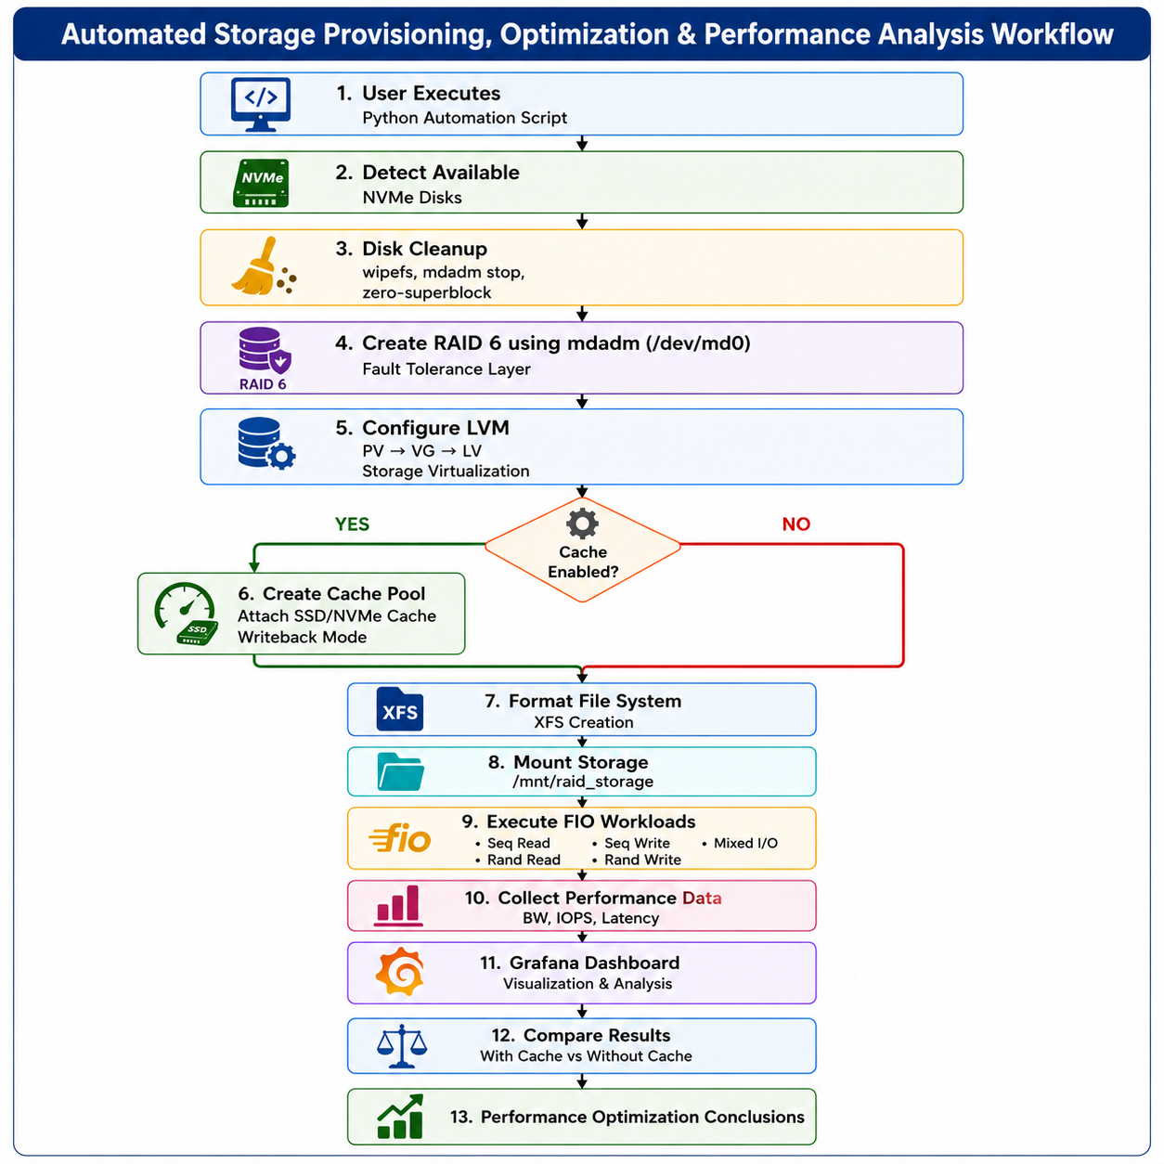

- 1. User Executes Python Automation Script
The workflow begins when the user runs the Python automation script through a menu-driven interface. It automates storage provisioning, benchmarking, monitoring, and cleanup operations.

- 2. Detect Available NVMe Disks
The script scans the system and detects all available NVMe storage devices. The user selects the disks to be used for RAID creation and optional SSD caching.

- 3. Disk Cleanup
Previously existing RAID metadata, filesystem signatures, and superblocks are removed from the selected disks. This ensures a clean storage environment before configuration begins.

- 4. Create RAID 6 using mdadm
The selected disks are combined into a RAID 6 array using mdadm to provide fault tolerance. The array can withstand up to two simultaneous disk failures while maintaining data availability.

- 5. Configure LVM
The RAID device is configured into Physical Volume (PV), Volume Group (VG), and Logical Volume (LV). LVM provides flexible storage management and enables SSD cache integration.

- 6. Create Cache Pool (Optional)
If caching is enabled, an NVMe SSD is attached as an LVM cache pool operating in writeback mode. Frequently accessed data is automatically stored in the SSD to improve performance.
- 7. Format File System
The logical volume is formatted with the XFS file system. XFS is chosen for its scalability, high throughput, and efficient handling of large storage workloads.

- 8. Mount Storage
The formatted logical volume is mounted at /mnt/raid_storage. This makes the storage available for applications and benchmarking operations.

- 9. Execute FIO Workloads
FIO generates sequential, random, and mixed read/write workloads to evaluate storage performance. These tests simulate real-world enterprise I/O operations.

- 10. Collect Performance Data
Performance metrics such as bandwidth, IOPS, and latency are collected during FIO execution. The results are saved in JSON format for further analysis.

- 11. Grafana Dashboard
The collected performance metrics are stored in InfluxDB and visualized using Grafana dashboards. Interactive graphs provide real-time insights into storage performance.

- 12. Compare Results
Benchmark results with SSD cache are compared against results without cache. This comparison highlights improvements in throughput, IOPS, and latency.

- 13. Performance Optimization Conclusions
The final analysis evaluates the effectiveness of adaptive SSD caching in improving storage performance. The project demonstrates a reliable and cost-effective software-defined storage solution for enterprise workloads.

3. Software Environment

3.1: Rocky Linux
Rocky Linux is an enterprise-grade, open-source Linux operating system that is fully compatible with Red Hat Enterprise Linux (RHEL). It is designed to provide stability, reliability, and long-term support for enterprise applications. In this project, Rocky Linux served as the primary operating system for configuring and managing the Software Defined Storage (SDS) environment.
Rocky Linux was selected because it provides native support for storage management tools such as mdadm for software RAID, Logical Volume Manager (LVM) for flexible storage allocation, and secure remote administration through SSH. Its lightweight architecture and efficient resource management make it well suited for high-performance storage systems.
The operating system was used to create RAID arrays, configure logical volumes, mount storage devices, manage SSD caching mechanisms, execute FIO benchmarking workloads, and support Grafana-based monitoring. Its command-line interface also enabled efficient automation and scripting of storage management tasks.

Key Features
- Enterprise-grade stability and reliability
- Fully compatible with Red Hat Enterprise Linux (RHEL)
- Native support for RAID, LVM, and storage management
- Secure remote administration using SSH
- Efficient resource utilization for storage-intensive workloads

3.2: SSH Setup

Secure Shell (SSH) Configuration
Secure Shell (SSH) is a secure network protocol used for remote administration of Linux systems. In this project, SSH was used to establish a secure connection between a Windows workstation and the Rocky Linux storage server using the PuTTY SSH client.
SSH encrypts all communication between the client and the server, ensuring secure authentication and protecting transmitted data from unauthorized access. Once connected, Linux commands can be executed remotely without requiring physical access to the server.
The SSH setup enabled efficient configuration of RAID arrays, Logical Volume Management (LVM), SSD cache configuration, execution of FIO benchmarking scripts, and monitoring of system performance throughout the project.

SSH Configuration Steps
- Install and configure the OpenSSH server on Rocky Linux.
- Start and enable the SSH service.
- Obtain the server's IP address.
- Use PuTTY on Windows to establish an SSH connection.
- Authenticate using valid Linux user credentials.
- Perform remote administration and benchmarking tasks.

4. IMPLEMENTATION DETAILS

4.1 RAID6 CONFIGURATION (mdadm)

The storage infrastructure was established using RAID 6 through the Linux mdadm utility to provide fault tolerance and data reliability. Four storage disks were combined into a single logical RAID device (/dev/md0) using the mdadm --create command. During array creation, parity initialization was automatically performed by the Linux RAID subsystem, enabling the system to recover data even if up to two disks fail simultaneously. RAID 6 was selected because it offers high reliability and is well suited for enterprise storage environments.
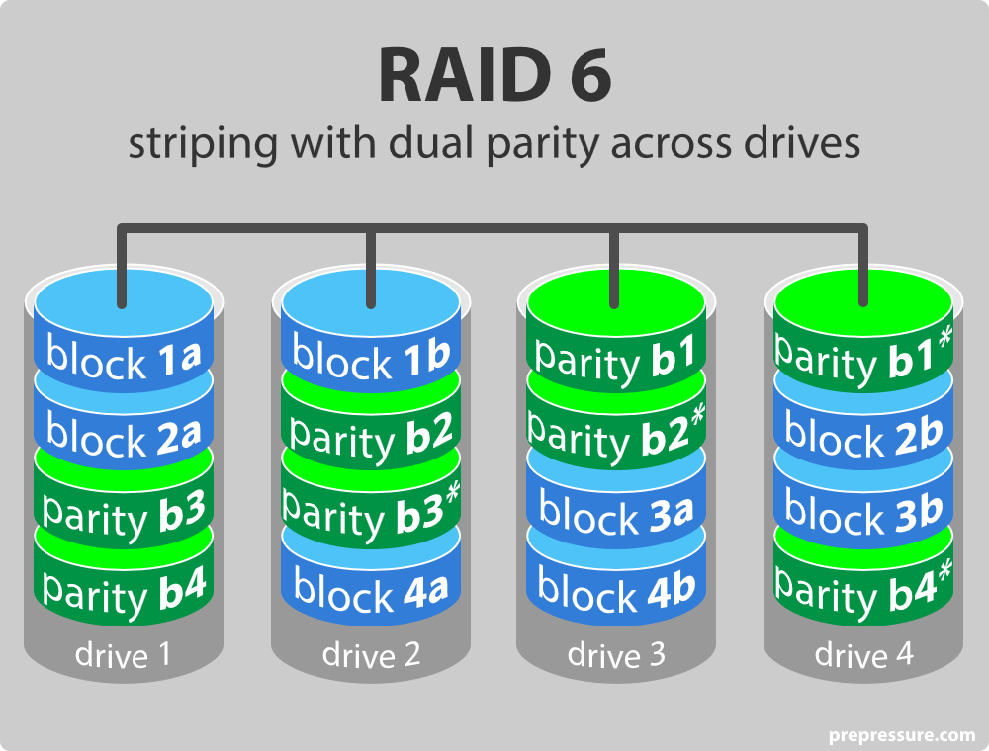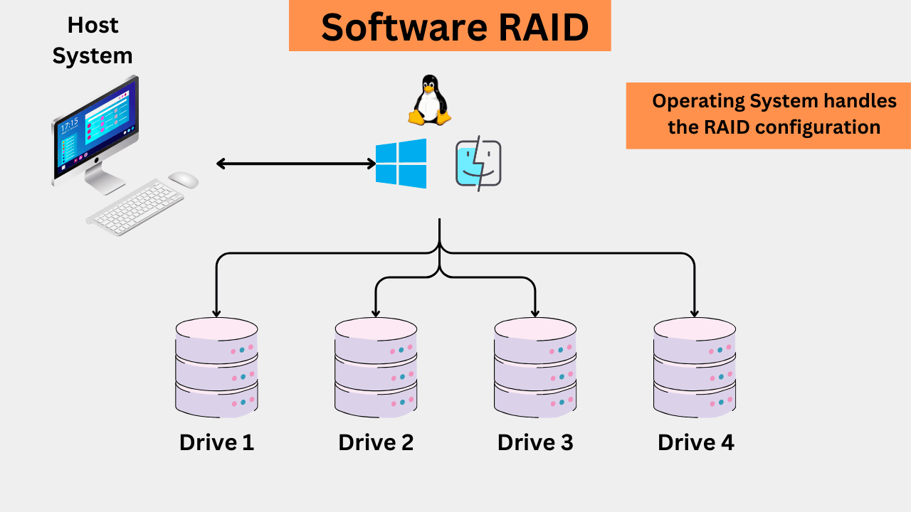

4.2 LVM PROVISIONING AND XFS FILESYSTEM
After the RAID array was created, parity initialization was automatically initiated to compute and distribute parity information across the disks. Instead of storing duplicate data, RAID 6 generates mathematical parity blocks that allow lost data to be reconstructed during disk failures. Although this process temporarily increases CPU and disk utilization, it ensures complete fault tolerance and consistent data protection once initialization is finished.
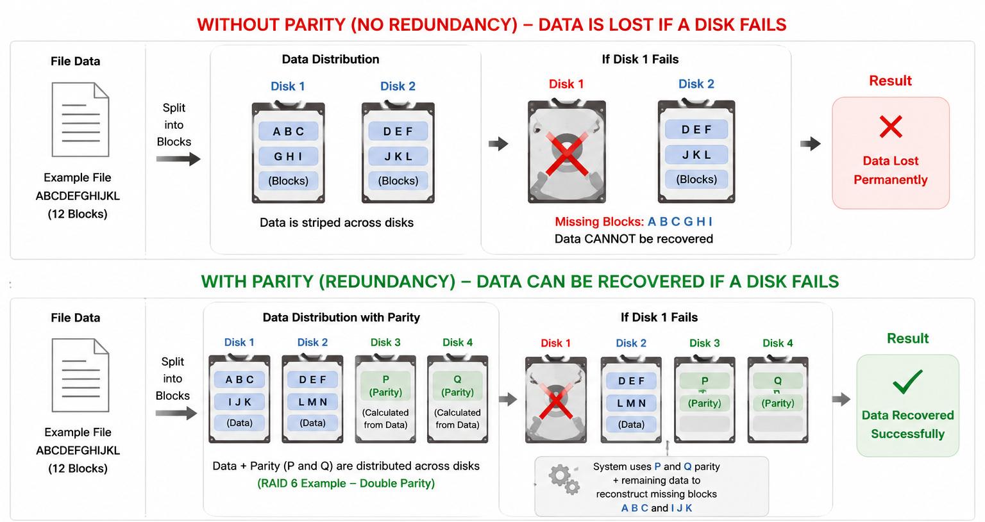

4.3 Hybrid Storage Architecture
The project employs a Hybrid Storage Architecture that combines Hard Disk Drives (HDDs) with Solid State Drives (SSDs) to achieve both high storage capacity and improved performance. While HDDs provide economical large-capacity storage, SSDs offer significantly lower latency and higher input/output performance.
A RAID6 array was created using multiple HDDs to ensure data redundancy and fault tolerance. An SSD was then configured as a caching layer to store frequently accessed data blocks. During read operations, the system first checks whether the requested data exists in the SSD cache. If found, the data is served directly from the SSD, reducing access time. Otherwise, the data is retrieved from the HDD array and may subsequently be cached for future requests.
This architecture balances cost, performance, and reliability by utilizing the strengths of both storage media while minimizing their individual limitations.

4.4 SSD CACHING USING LVM CACHE
To improve the performance limitations introduced by RAID 6 parity calculations, an SSD-based caching layer was implemented using LVM Cache. The SSD was added as a cache pool to the existing logical volume, allowing the system to automatically move frequently accessed ("hot") data to the SSD while retaining less frequently used ("cold") data on the HDD-based RAID array. This transparent caching mechanism significantly improves read and write performance without requiring manual data management.
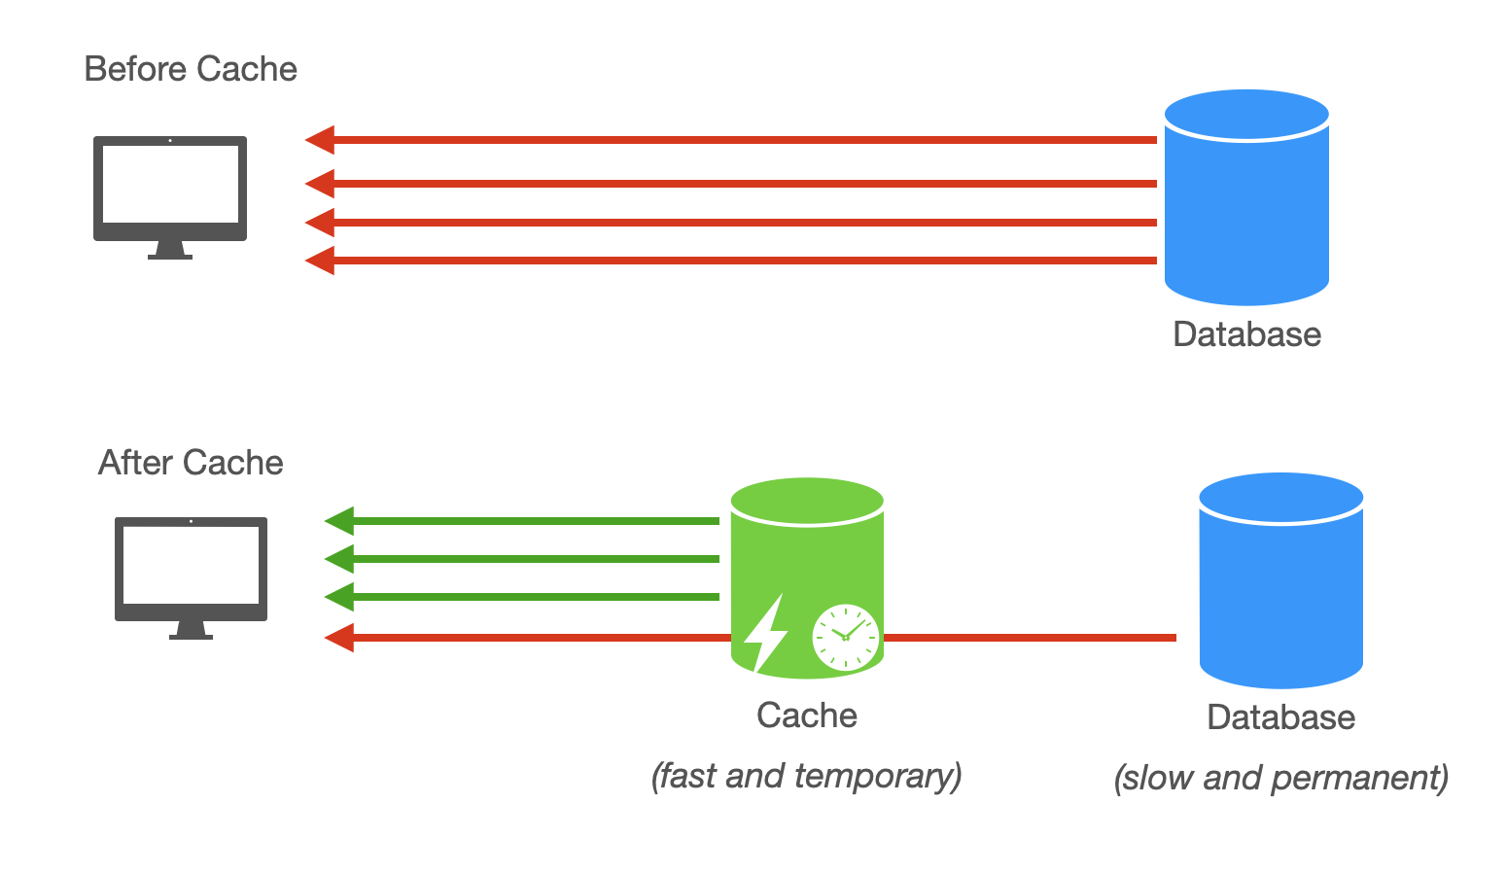

4.5 PERFORMANCE COMPARISON: WITHOUT CACHE vs WITH CACHE
After implementing SSD caching, the storage system was evaluated to compare its performance with and without cache. In the traditional RAID 6 setup, every read and write request is handled directly by the HDDs, leading to higher latency and lower throughput due to mechanical disk access and parity calculations. With SSD cache enabled, frequently accessed (hot) data is served directly from the SSD, significantly reducing access time and improving overall system performance.The comparison showed noticeable improvements in read speed, IOPS, response time, and throughput while reducing HDD workload and latency.
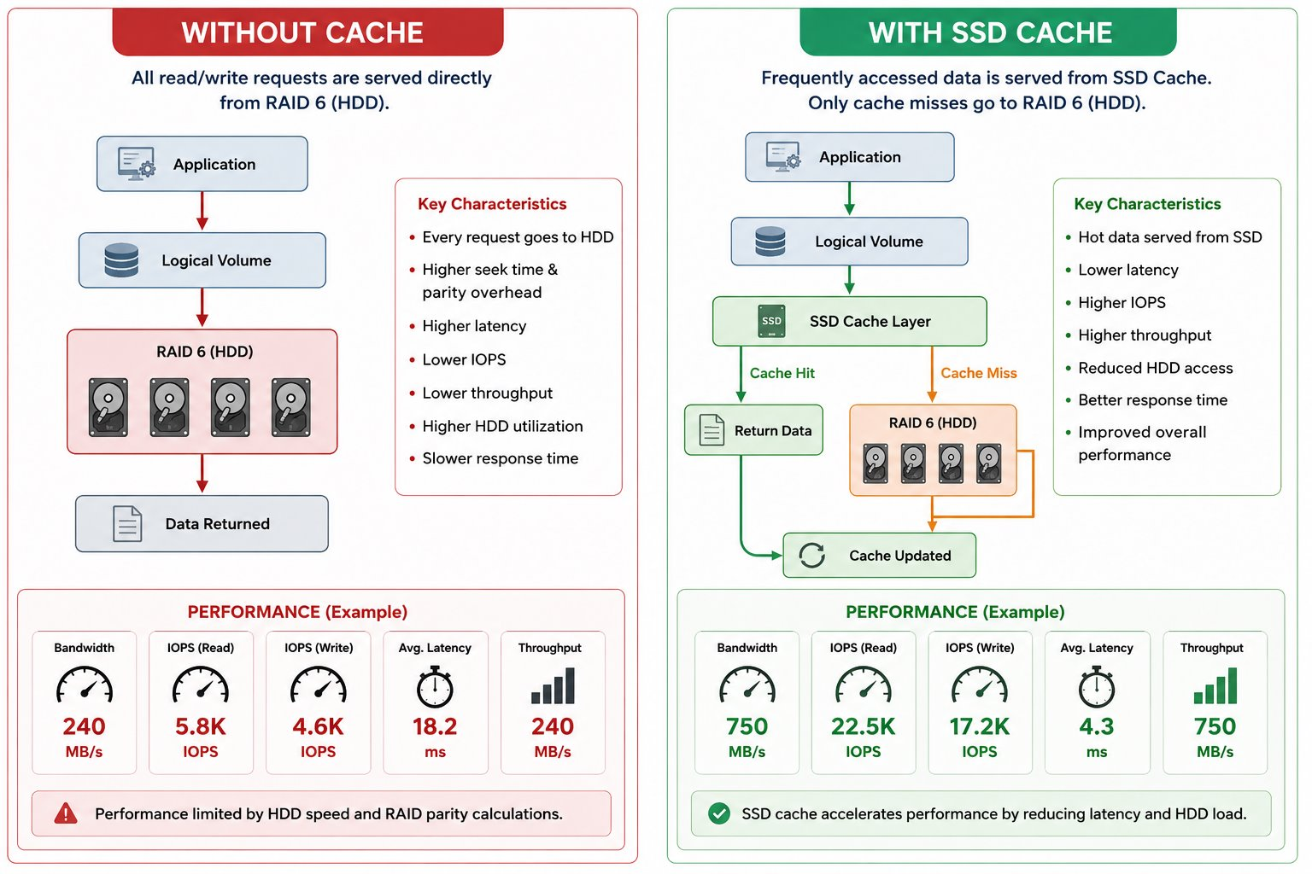4.6 LOGICAL VOLUME MANAGER (LVM) CONFIGURATION
After creating the RAID 6 array, Logical Volume Manager (LVM) was configured to provide a flexible and efficient storage management layer. The RAID device was first initialized as a Physical Volume (PV), which serves as the foundation for LVM. This Physical Volume was then added to a Volume Group (VG), creating a unified storage pool from which storage could be allocated. A Logical Volume (LV) was created from the Volume Group and formatted with the XFS file system before being mounted for use. This configuration enables efficient storage utilization, simplifies storage management, and allows future expansion or resizing of storage without modifying the underlying physical disks.
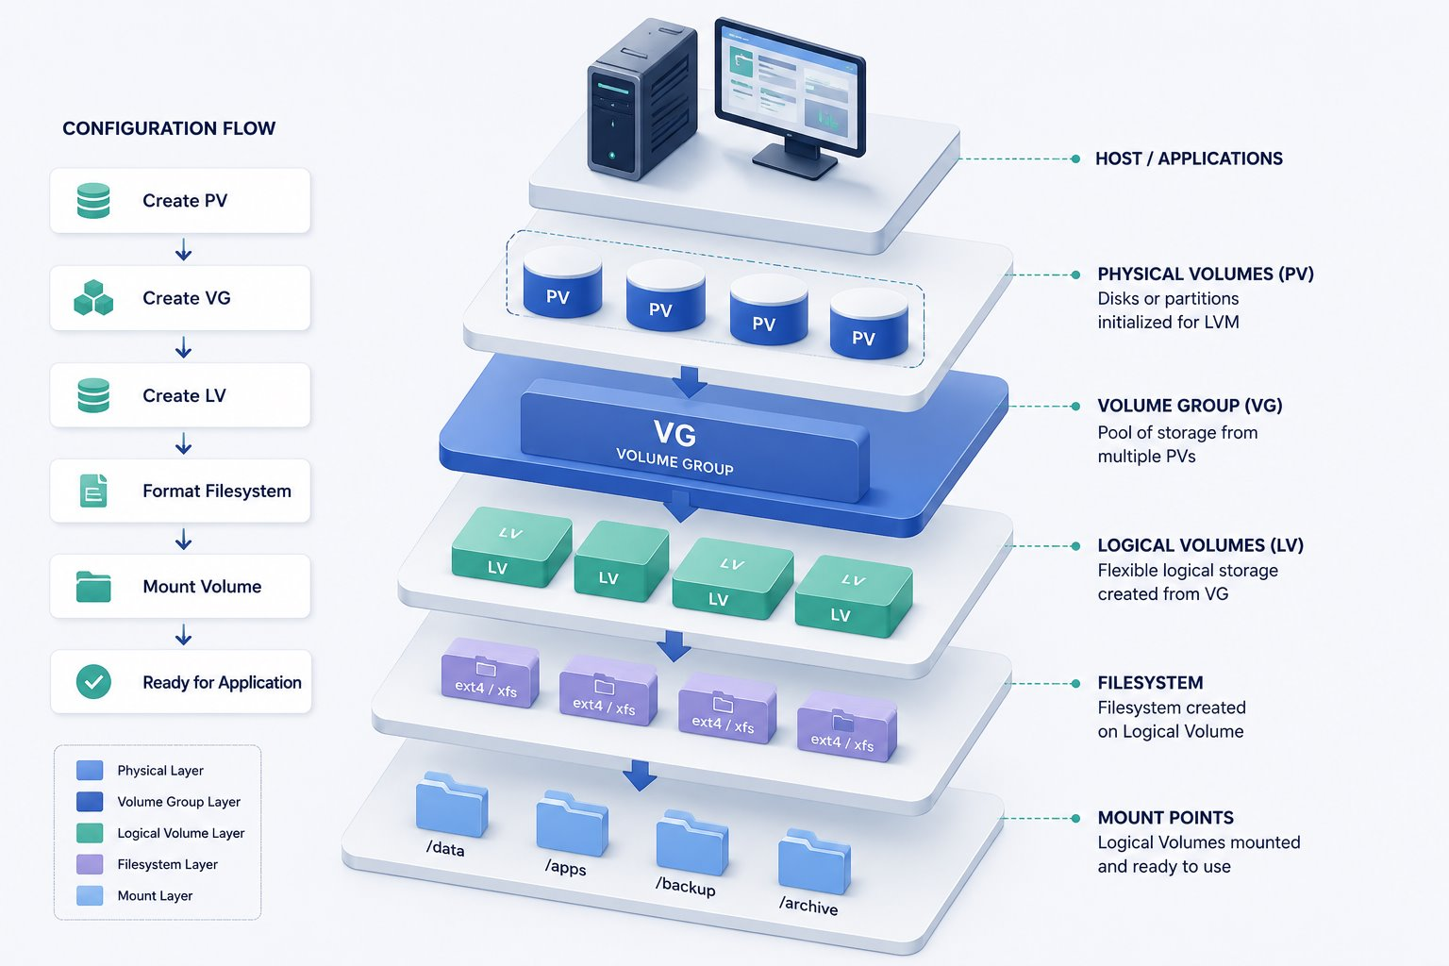
4.7 RESOURCE RECLAMATION
Before performing resource reclamation, the storage environment was cleaned by removing temporary files, test data, and other unnecessary resources generated during implementation and benchmarking. This storage cleanup ensured that only valid data remained, making the unused storage blocks available for reclamation. After the cleanup process, the fstrim command was executed to notify the SSD about the blocks that were no longer in use, allowing them to be efficiently reused for future write operations. The reclaimed storage was then verified using system monitoring commands to confirm successful execution. This combined process improved storage utilization, reduced unnecessary write operations, and helped maintain the long-term efficiency and performance of the software-defined storage system.
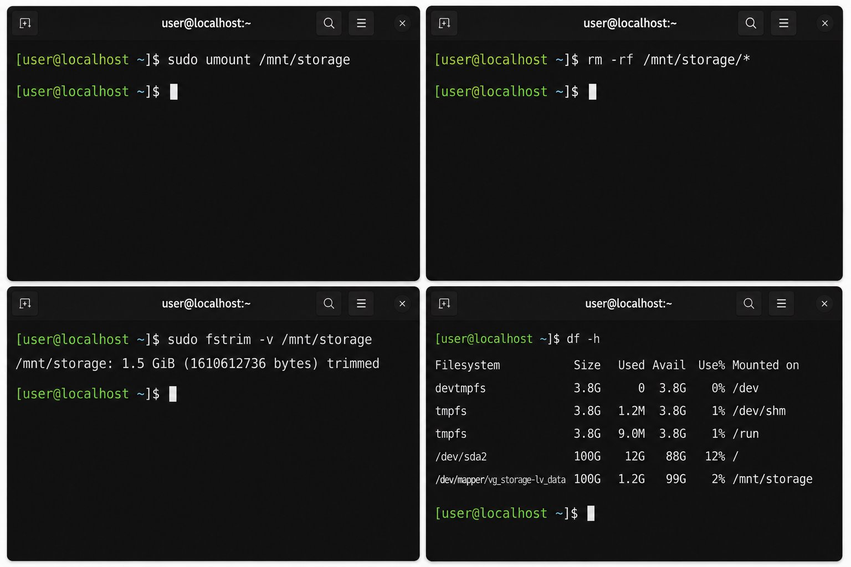

5. Benchmarking with FIO
To rigorously validate the architectural benefits of the cache, the team utilized FIO (Flexible I/O Tester). The benchmark tested the deployment under severe, simulated application conditions leveraging the libaio engine and a high I/O depth (e.g., iodepth=16 with 4k block sizes). The following tests were executed:
- Random Read/Write (70/30 split): Simulating database patterns and volatile workloads.
- Sequential Read: Measuring sustained bandwidth for large media/streaming files.
- Sequential Write: Testing raw data ingestion and parity overhead.

FIO Command:

Random read/write - Simulates real-world mixed workloads.
>>fio --name=randrw --filename=testfile \
--size=200M --bs=4k --rw=randrw \
--rwmixread=70 --ioengine=libaio \
--iodepth=16

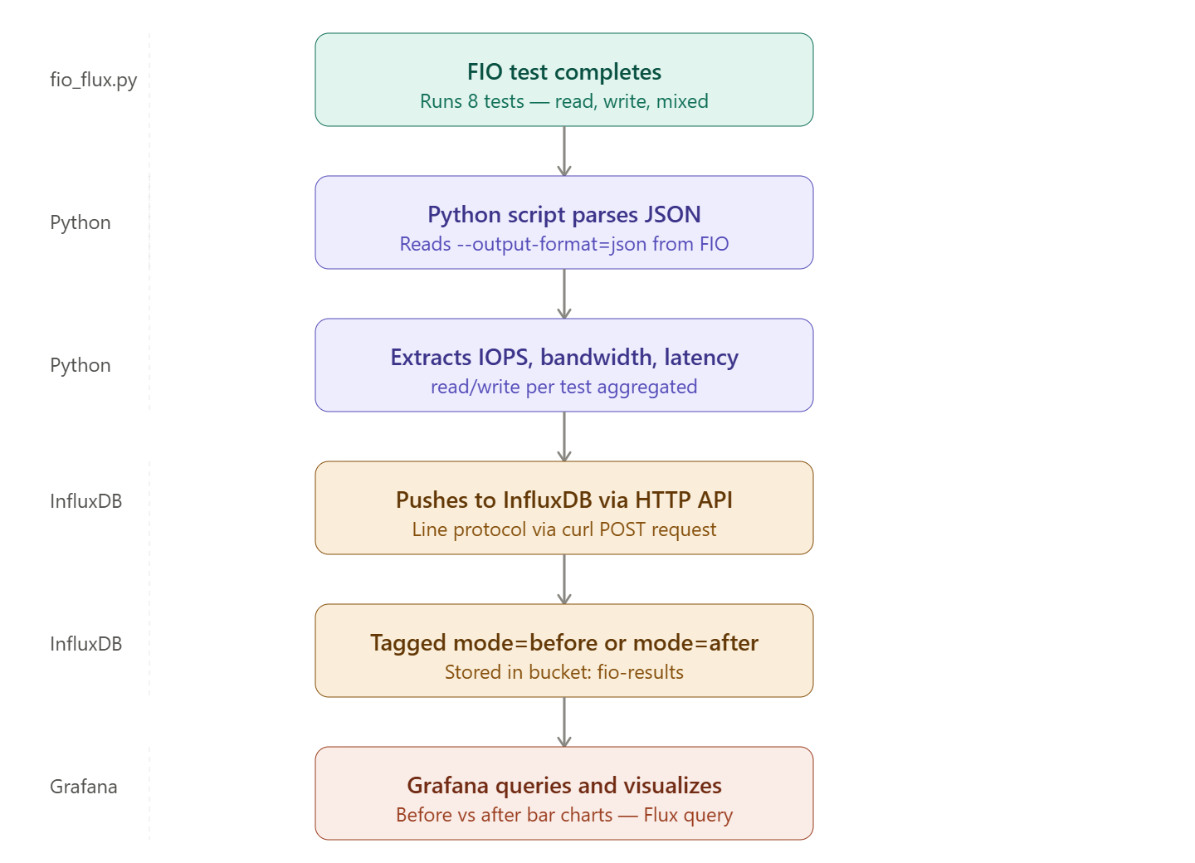
FIO to Grafana Visualization Workflow
The process was executed in two phases: Phase 1 operated strictly on the base RAID 6 array without caching to act as a control metric. Phase 2 enabled the LVM Cache. We allowed the cache to "warm up" via preliminary reads. The comparative findings highlighted a colossal shift—response times plummeted from milliseconds to microseconds, and Input/Output Operations Per Second (IOPS) scaled drastically higher.

6. Monitoring with InfluxDB and Grafana
Capturing real-time execution changes was imperative for proving the mechanism’s efficacy. As FIO pushed payloads onto the storage array, statistical outputs were routed continuously into InfluxDB, an optimized time-series database. Grafana securely linked to InfluxDB as a data source using the Flux query language. Customized visual dashboards were designed to map performance. These dynamic charts easily portrayed stark visual disparities; for example, portraying a low-flat line of IOPS during Phase 1 that aggressively spiked to high sustained values immediately upon activating the SSD via Phase 2.

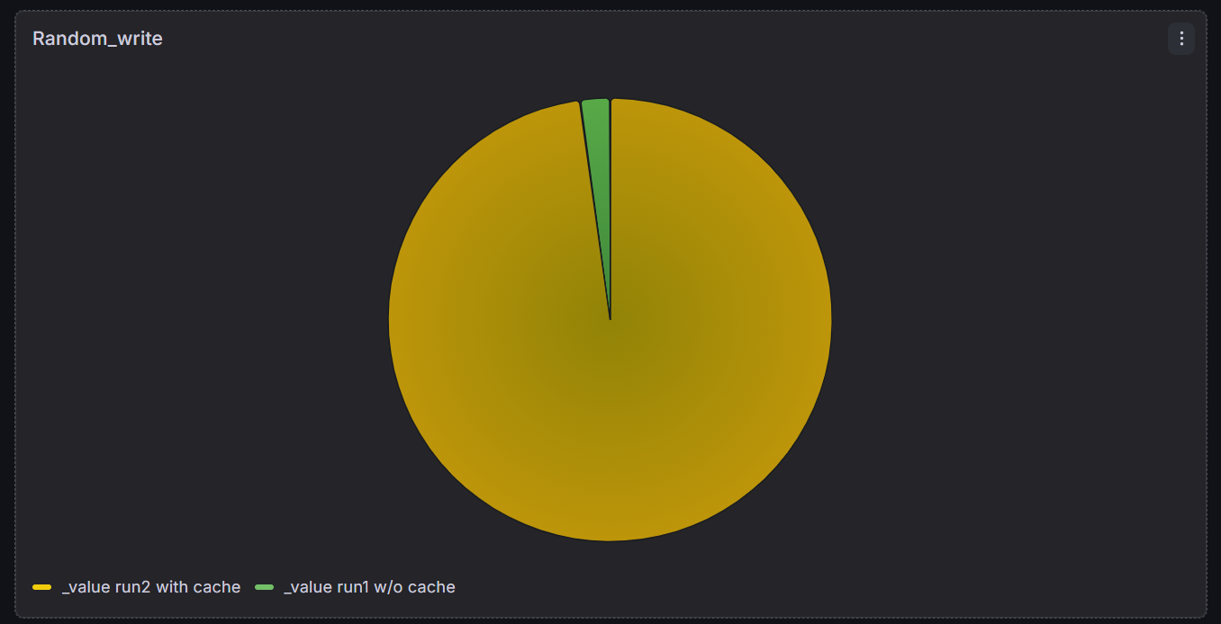
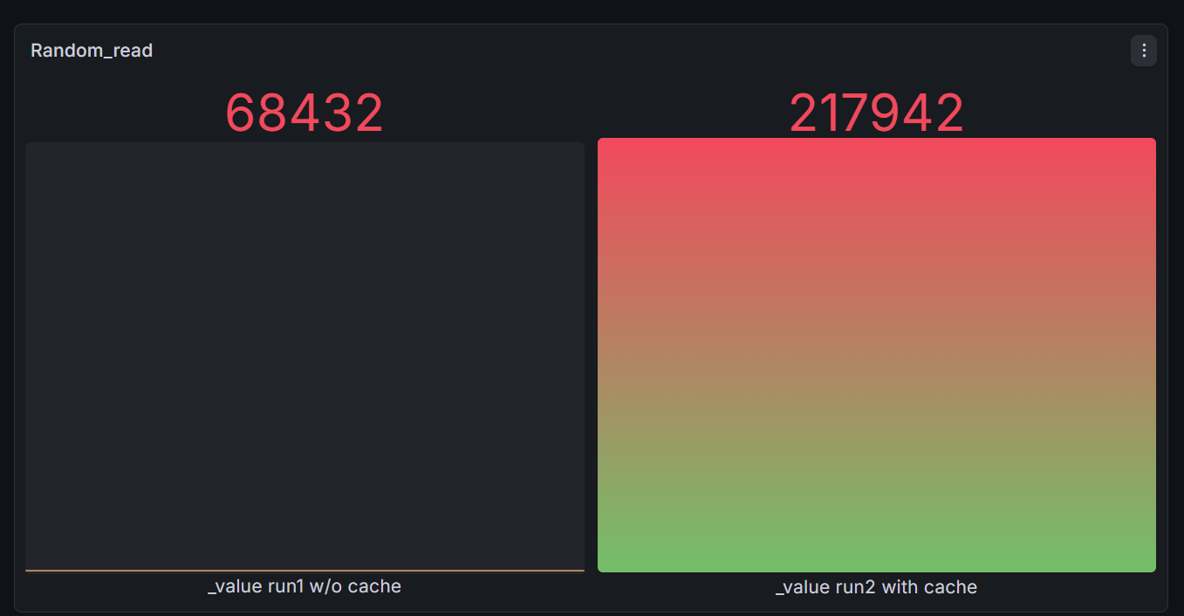

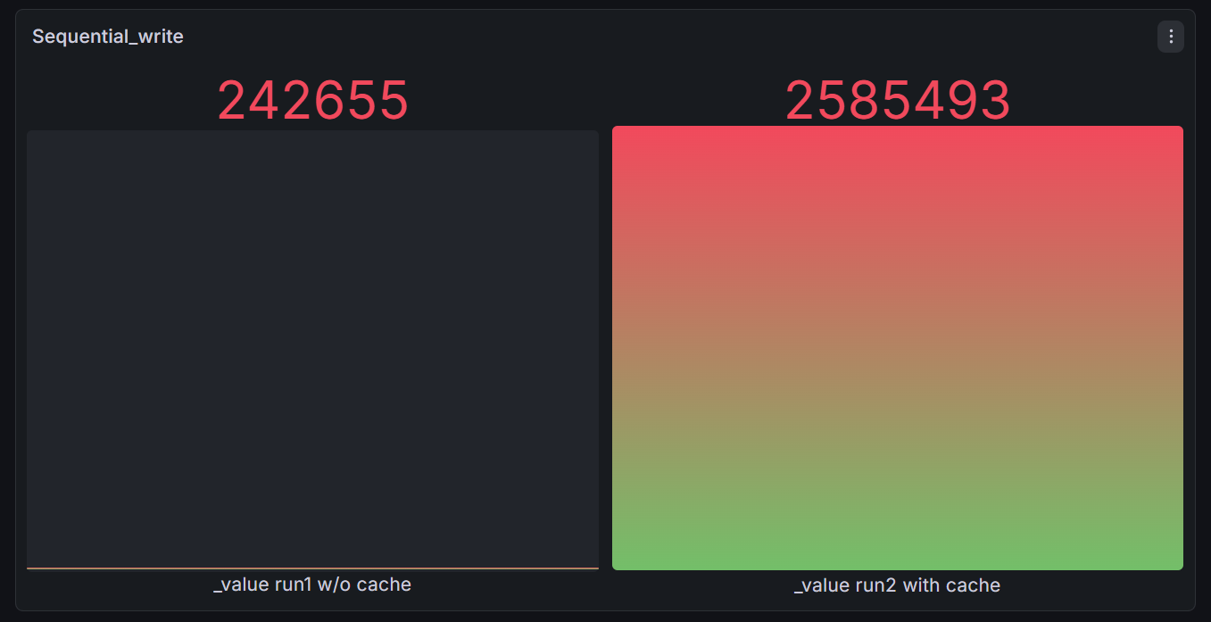
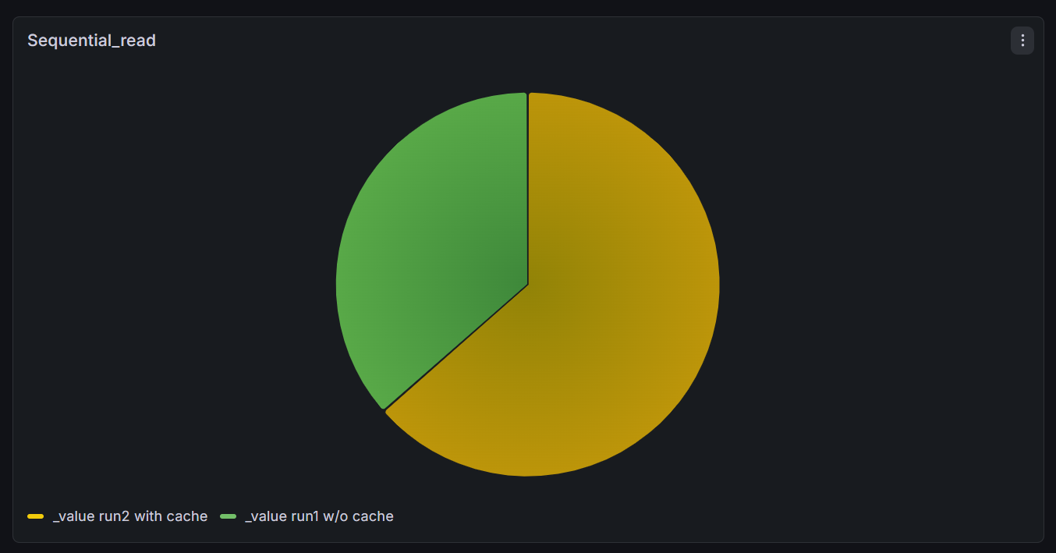

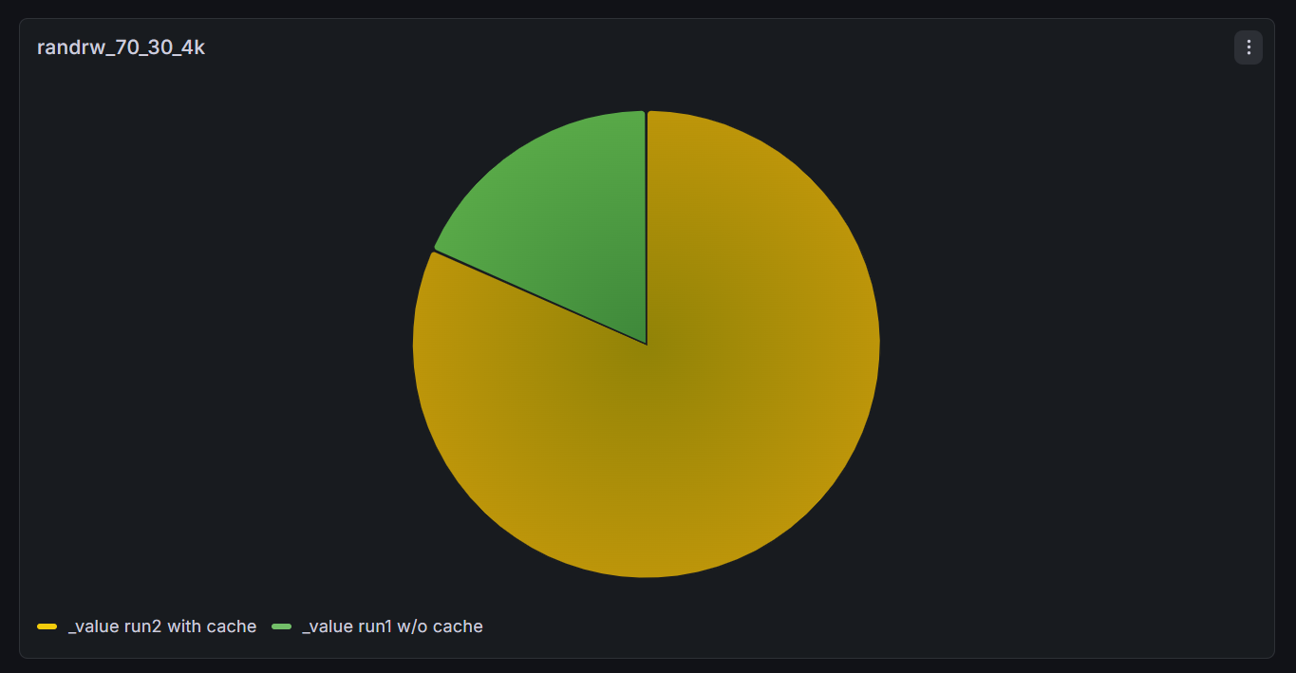

Grafana Dashboard Result

7. Conclusion
This project conclusively demonstrates that introducing an LVM SSD Cache over a software-based mdadm RAID 6 array is a profoundly effective storage optimization strategy. By capitalizing on an enterprise-grade Rocky Linux environment and leaning on robust standards like the XFS file system, organizations can achieve the massive, economical capacity of HDDs while operating at the blistering speed of flash media. Verified by rigorous FIO testing and clearly depicted through automated Grafana dashboards, adaptive tiering mitigates mechanical seek times and parity lag. This framework provides an excellent, scalable, and highly available Software-Defined Storage architecture suitable for demanding, data-intensive data center applications.

